York Architecture Images – Upper East Side of New York
THE SHERRY NETHERLAND HOTEL
Architect: Schulze & Weaver and Buchman & Kahn
Location: 781 Fifth Avenue, New York, NY
Date: 1927
Style: Art Deco
Construction:
Above the four-story, travertine-clad base, the building rises as a plot-sized dark brown brick mass until set back and turned into a tower; above the 24th floor, each floor has only one apartment. The spirelike top with French Chateau influences houses the water tower, topped by a perched observation balcony at 173.5 m.

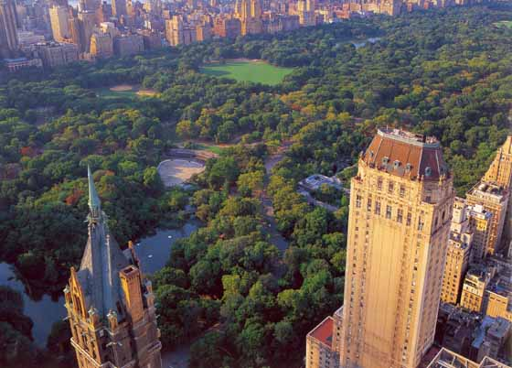
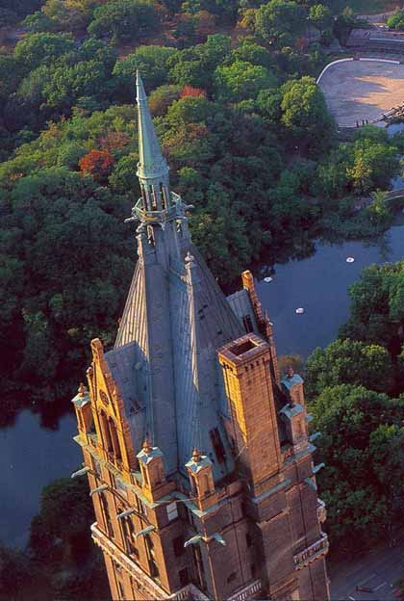
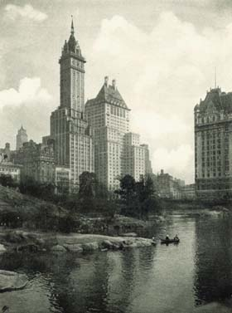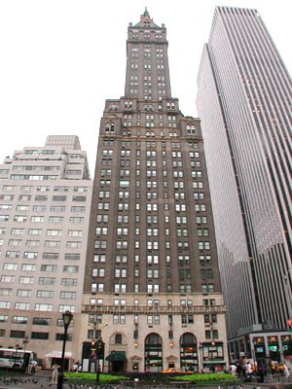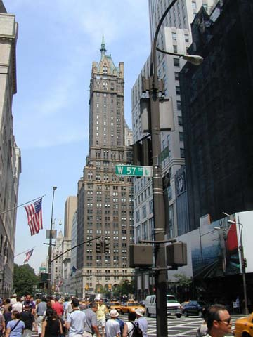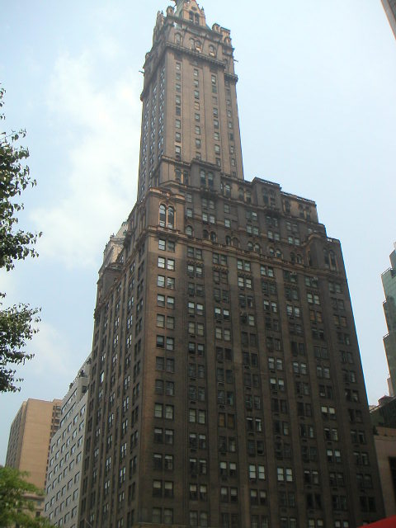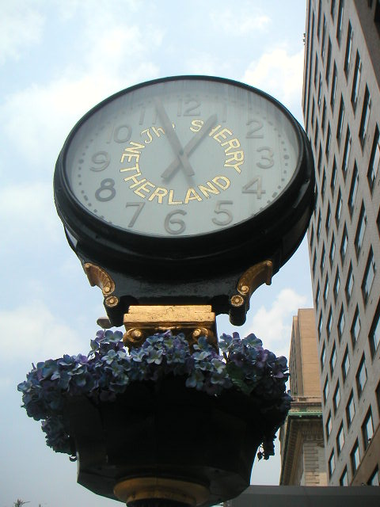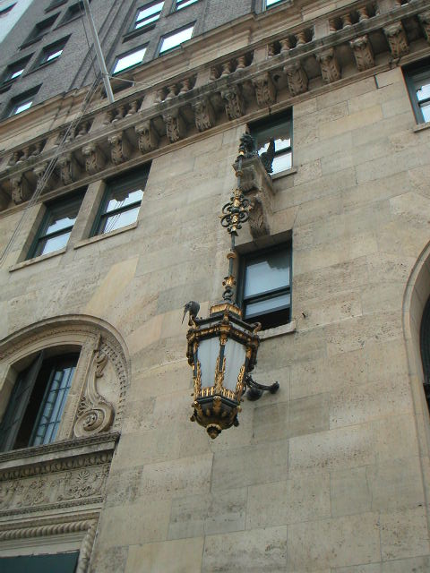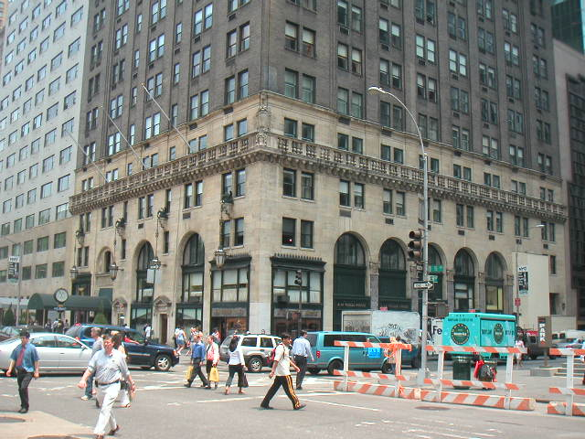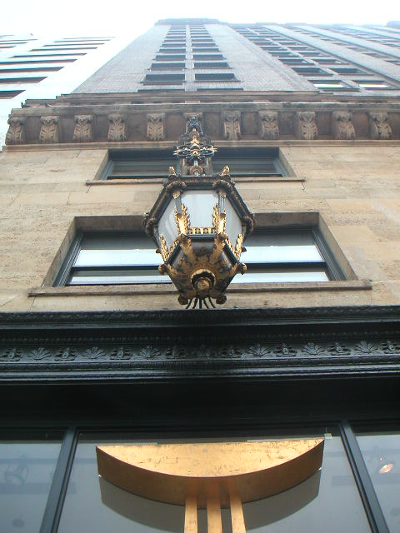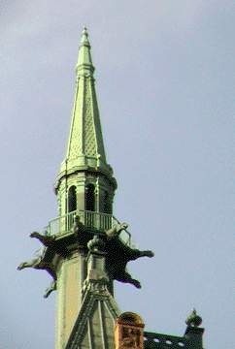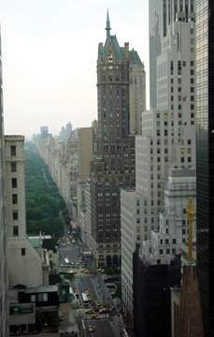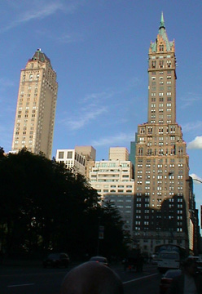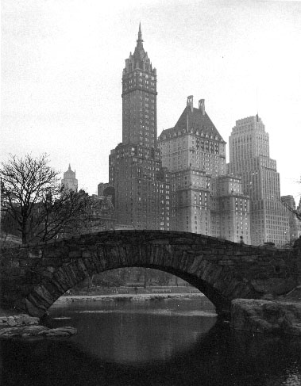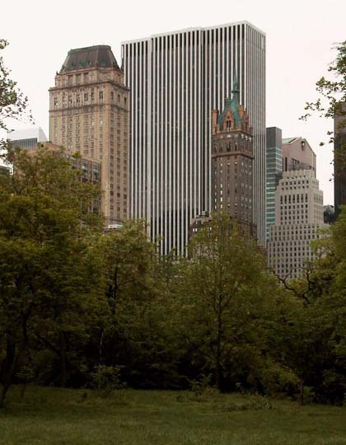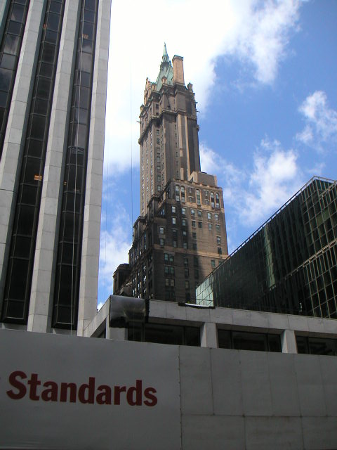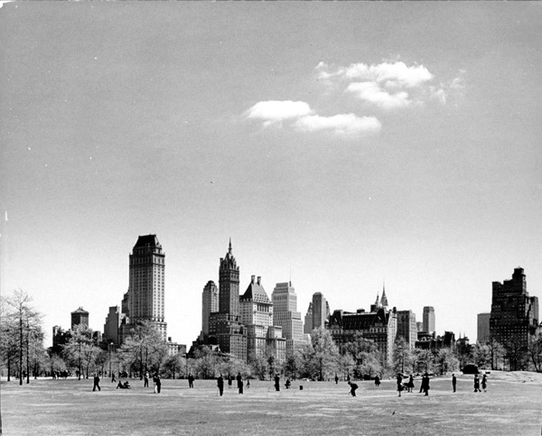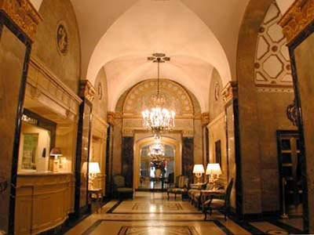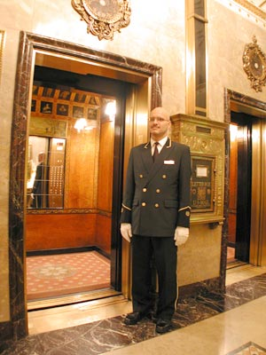

Special thanks to Carter B. Horsley of The City Review.
According to authors Stern, Gilmartin and Mellins, Buchman & Kahn assisted Schultze & Weaver in the design of the Sherry Netherland Hotel that replaced William H. Hume's New Netherland Hotel of 1892, "one of the city's first steel-framed buildings." They also noted that the small lobby entrance is adorned with sculpture panels salvaged from the William K. Vanderbilt mansion that was demolished to make way for the Bergdorf Goodman store nearby on the southwest corner of the avenue at 58th Street. During its construction, a major fire broke out in its scaffolding before its standpipes were functioning, but the hotel was not destroyed. The 570-foot-high, 38-story building was the world's tallest apartment hotel when it was opened and all the floors above the 24th had only one apartment each
Because it was erected during the Prohibition, the Sherry Netherland, shown at the left from across Fifth Avenue, developed by Louis Sherry and Lucius Boomer, did not have major dining facilities, although its basement was converted in the 1970's to a very exclusive private disco and restaurant known as Raffles that within a few years was renamed Doubles and redesigned by Valerian Rybar in bright red colors. It remains one of the most elegant and exclusive nightspots in the city for its members
Unlike the Pierre, which was located in a residential zone, the Sherry Netherlands's retail frontage has always been supremely elegant. The long-term tenant of the corner store has been La Vieille Russe, specializing in extravagant Russian bibelots. South of the entrance, the restaurant space has been operated for several years by Harry Cipriani as one of the city's most elegant restaurants. North of the entrance, Diane von Furstenberg commissioned architect Michael Graves to design an opulent salon in 1984 that was subsequently taken over by Geoffrey Beene. It is the best design by Graves, a great draftsman who is a far better designer of storefronts and kitchen appliances than buildings.
The base of the hotel, shown at the right, is the most elegant and wonderful in the city because of its travertine marble facing and, most particularly, its fantastic griffins with hanging lanterns. The subdued, understated ambiance of the Sherry Netherlands's small lobby exudes refinement and attracts the world's elite. While the griffin lanterns may frighten off the hoi-polloi, the elegant sidewalk clock is a very handsome public gesture.
One of the great joys of life must be a walk around the tiny parapet at the base of the hotel's crowning fleche.
Despite its relative modest size, the Sherry Netherlands must be considered one of the world's greatest skyscrapers and is, in my opinion, the best in midtown. The monumental scale of the Chrysler and Empire State Buildings have made them more famous, but the Sherry Netherlands comes closer to perfection in its massing and wondrous top. (The original R.C.A. building that became the original G.E. building and is now simply 570 Lexington Avenue comes in second, closely followed by the Chanin Building at 122 East 42nd Street whose decorative elements, especially within its lobby, are masterpieces of modern art.) The Woolworth Building probably qualifies as the best skyscraper downtown while the Metropolitan Insurance Company tower on Madison Avenue at 24th Street is the best in Midtown South.)

